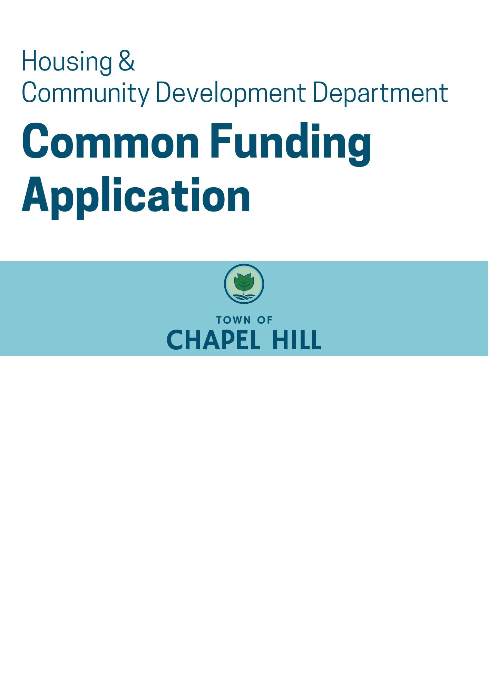
Housing and Community Development Department
housingandcommunity@townofchapelhill.org
919-968-2877
https://www.chapelhillnc.gov/Town-Government/Departments-and-Offices/Housing-and-Community-Development

GENERAL INFORMATION & APPLICATION INSTRUCTIONS

OVERVIEW
Thank you for your interest in the Town of Chapel Hill’s Affordable Housing and Community Development funding sources! This application is used for funding requests for the Town’s local affordable housing funding and the federal Community Development Block Grant (CDBG) funding. To learn more about each of these sources and eligible uses, see the Local Affordable Housing Funding Program webpage.

This February 2026 application cycle only includes Community Development Block Grant (CDBG) funding.

INFORMATION SESSION
Applicants are invited to attend an optional information session prior to applying for funding. Information about how to register will be posted here.

Applicants are also invited to participate in a one-on-one pre-application meeting to discuss their funding proposal with Town staff. To schedule a pre-application meeting, contact Melissa Peters at mpeters2@townofchapelhill.org.

SUBMISSION INSTRUCTIONS
Applications must be submitted electronically in PDF form to: housingandcommunity@townofchapelhill.org.

Throughout the application, applicants may expand the space under each question as needed to provide a complete answer.

THRESHOLD CRITERIA

Applications may be withdrawn from consideration for the following reasons:
- Projects are not located within the Town limits or the Town Extra-Territorial Jurisdiction (ETJ)
- Projects do not have site control (if applicable)
- Projects do not align with the eligibility criteria for the funding source; see allocation strategy and CDBG program summary linked in Overview section above.
- Incomplete or late applications

APPLICATION EVALUATION
Staff will evaluate funding applications with the scoring rubrics posted here.

TABLE OF CONTENTS

- Cover Page
- Organization Information
- Project Information
- Community Connections

- Required Attachments
6. Appendix A: HUD Income Limits And Maximum Housing Costs
7. Appendix B: Summary Of Eligible Uses By Funding Source

1. COVER PAGE

Organization Contact Information
Legal Name: Tax ID Number:

Physical Address: Mailing Address:

Organization’s Website: Date of Incorporation:

Executive Director Name:

Telephone Number: E-Mail:

Funding Request. Respond to questions as applicable.
Project Name:

Total Number of Units Supported/Households Served in Project:

Total Number of Units Supported/Households Served by this Funding Request:

Total Project Cost: Total Amount of Funds Requested:

Proposed Use of Funds Requested (provide a concise description, not to exceed 100 words):

Type of Activity. Please check the category under which your project falls.

Land Acquisition and land banking
Future development planning
Infrastructure/site improvements
Construction of new affordable housing (NA)
Public services (see CDBG Funding Guide)
Economic development (see CDBG Funding Guide)
Rental, utility, and relocation assistance
Financial assistance to homeowners
Rehabilitation and redevelopment
Other (specify):

To the best of my knowledge and belief all information and data in this application is true and current. The document has been duly authorized by the governing board of the applicant.

Signature:
Executive Director DateNIZATION INFORMATION

2. ORGANIZATION INFORMATION

1. Organization Mission (no more than a few sentences):

- Organization Staff: Please provide names of staff, contractors, and/or volunteers that will be involved with the project. Briefly describe their responsibilities with the project and track record in successful completion of similar projects in the past.

# of FTE – Full-Time Paid Positions:
# of FTE Part-Time (less than 40 hours/wk) Paid Positions:

- Agency Track Record: Briefly describe three relevant and substantially similar affordable housing or community development projects completed by the organization in the last 10 years (preferably 5 years). The project description should include:
- Location
- Scope and scale of project
- Total budget and financing sources
- Indication of whether the projects were completed on budget and on time. If not completed on budget and on time, please describe why.
- Photos/illustrations of completed project

- Town Funding Experience: For all projects for which you have received Town of Chapel Hill funding within the last 5 years, please provide the information below.

NOTE: If you have not previously received Town funding for a project indicate N/A for this question.

Project Name | Project Type | Year Funding Awarded | Amount of Funding Approved | Project Complete? (Yes/No) | If Complete: Was project completed on schedule and within budget? If not, why?  If Not Complete: is the project meeting key milestones outlined in the funding commitment?
*Add rows as needed to reflect additional projects that have received Town funding within the last 5 years.

3. PROJECT INFORMATION

- Project Description: Provide a general overview of your project. The overview should include:
- A project description
- What you are planning to achieve
- How you are planning to carry out the project
- Whether the requested funding is for a new or expanded/improved service

- Community Needs: Briefly describe how your project or program addresses unmet needs and (if applicable) underserved populations within the community. (100 words maximum)

- Program Goals: Complete the following chart with information about the program’s goals and performance measures.
Goal | Performance Measurement
Ex: Provide housing for low- to moderate-income households. | Ex: By 2027, preserve ten units that are affordable to low- to moderate-income households.

- Project Profile: Insert project information below as applicable.
Location:
(insert address if available)
Total Number of Units:
Unit Size | # of Total Housing Units | Square Footage | Proposed Rent or Sale Price Per Unit
Studios
One-bedroom
Two-bedroom
Three-bedroom
Four-bedroom
Area Median Income Served  (insert # of units/persons by AMI) | # Units/ Persons
<30%
31-60%
61-80%
81-100%
>100%
Target Population
(check all that apply)
Families
Older Adults (Age 55+)
People Living with Disabilities
People Experiencing Homeless
Persons with HIV/AIDS
Veterans
Other (specify)
ADA Accessibility:
(insert # of total units)
Will this project include or support permanent supportive housing? | Yes  No
Total Project Cost $________ | Total Project Cost Per Unit/Person $_______
Total Subsidy Requested $________ | Per Unit/Person Subsidy $_______ per unit/person
Town Planning Approvals Received:  (as of the date of application) | Zoning  Final Plans/Zoning Compliance Permit  Building Permits  None

- Affordability Term. What is your affordability term?
(indicate N/A if not applicable, such as for public service or economic development projects)

Briefly describe your methods to ensure the affordability of housing units (e.g., subsidy recapture, equity sharing, and deed restrictions.) (100 words maximum)

- Does your project align with the Town’s Source of Income Protections Policy that requires any rental housing that receives Town resources (funding or property) to accept all lawful sources of income, including housing choice vouchers?
☐ Yes
☐ No
☐ Not Applicable

- Leverage:
  - How much funding is committed to the project at the time of submission of this application? $
(Attach documentation of committed funding – e.g., funding commitment letters, funding agreements, etc.)

  - What percentage of funding for the proposed project will be leveraged from sources other than the Town? %
(Attach documentation of how you calculated the leverage percentage – i.e., Value of Non-Town sources / Total Project Budget).

4. COMMUNITY CONNECTIONS

- Please describe how you have involved potential beneficiaries of and/or communities served by the proposed project in the planning and design process. (100 words maximum)

- How do your organization goals reflect the needs of the population that you intend to serve with this grant? (100 words maximum)

- How do your staff and board reflect the populations that you intend to serve with this grant?

- Please fill in the table below about your organization and board leadership: (for informational use only; will not be used to score application)

AGENCY DEMOGRAPHICS
 |  | Staff | Board
Gender
Men
Women
Other
Total
Race and Ethnicity
Black or African American
American Indian or Alaska Native
Asian
White
Native Hawaiian or Other Pacific Islander
Some other race
Total
Of the above, how many Hispanic, Latino or Spanish origin
Of the above, how many non-Hispanic, Latino or Spanish origin
Total

- Please describe any additional activities your organization is doing to center the voices of households with lived experience in housing and/or economic challenges.

5. REQUIRED ATTACHMENTS
Multiple Applications

If your organization plans to submit multiple applications during this funding cycle, include all organizational attachments in the first application you submit. For any subsequent application(s), DO NOT include the organizational attachments. Instead, check the box below to indicate previous submission of required organization attachments.
☐ All required organizational attachments (Financial Audit, Organization Budget, Articles of Incorporation, List of Board of Directors, References, and Non-Profit or For-Profit Corporation Attachments) have been submitted with a prior 2026-2027 Affordable Housing & Community Development funding application
Description of Required Attachments

- Project Information
  - Detailed timeline showing when each work task will be completed over the duration of the project
  - Anticipated schedule of expenditure of the Town’s funding for the project
  - Rental income policy that will be used for the project (if applicable)
  - Background check policy that will be used to screen potential tenants (if applicable)
  - For site-specific development and renovation projects:
- Site map showing lot boundaries, locations of structure(s), and other site features
- General location map (at least ½ mile radius)
- Floor plan(s)
- Elevation(s)
- Property Appraisal
- Evidence of zoning compliance
- Documentation of building permit/Zoning Compliance Permits
- Map showing proximity to bus stops, shopping, grocery store, schools and other service and amenities (including distance in miles from project site and amenities)

- Project Financials
  - Project Budget, including Funding Sources and Project Uses/Costs (see Budget Template in application materials)
  - Evidence of funding commitments from non-Town sources (e.g. commitment letter, Council resolution, executed funding agreement)

- Financial Audit
Please include your organization’s most recent financial audit. For organizations with prior year revenues totaling $500,000 or more, a financial audit prepared by a certified public accountant is required. Agencies with prior year revenues of less than $500,000 may submit a completed Schedule of Receipts and Expenditures form (see application materials) in lieu of an audit/report. Agencies with a certified audit/report do not need to complete the form.
- Organization Budget
Please submit an organizational budget. Among other relevant revenue and expenditure information, please include line items on any government grants or loans by jurisdiction. If your organization has run a deficit, please include that information here.
- Articles of Incorporation

- List of Board of Directors
Provide the following information about each board of director’s member: name, occupation or affiliation of each member, officer positions.
- References
Provide two business references with name, address, and telephone number.
- CDBG Certifications

- Disclosure of Potential Conflicts of Interest and Non-Discrimination Clause
Read and sign to indicate any potential conflicts of interest and agree to the non-discrimination clause. See application materials.

- Acknowledgement Of Addendum To 2025-26 HUD CDBG Grant Agreement
Read and sign to show acknowledgement of the addendum. See application materials.

- Other Organizational Documents

  - Non-Profit Corporations:

- IRS Federal Form 990
A copy of the organization’s most recent Form 990 is required for nonprofit applicants. The specific form depends upon the organization’s financial activity. Review the IRS’ table guide for more details. For Form 990-N (e-postcard) filers, include a copy of the postcard with the organization’s application materials.
- NC Solicitation License
A copy of the organization’s current solicitation license is required. Organizations that solicit contributions in North Carolina directly or through a third party must renew their licenses annually. For more details, refer to the NC Secretary of State’s licensing website and its Frequently Asked Questions Guide (PDF), about exemptions. If exempt per N.C.G.S. § 131F-3, include a copy of the exemption letter with the organization’s application materials.

- IRS Federal Tax-Exemption Letter
A copy of the organization’s current IRS tax-exempt letter that confirms its nonprofit status is required. An organization can request a copy of its letter from the IRS’ Customer Account Services.

  - For-Profit Corporations:
- Tax Returns
Most recent two years of corporate tax returns.

- YTD Profit and Loss Statement and Balance Sheet

- Tax Returns
Most recent two years personal tax returns and financial statements for all persons who have more than 19.9% ownership interest in the organization

- Signed “Authorization to Release Information” for each person who has more than 19.9% ownership interest in the organization

- Completed W-9 Form

NOTE: Information submitted to the Town of Chapel Hill is public information and is available upon request in accordance with the North Carolina Public Information Act. As provided by North Carolina statute and rule, the Town will consider keeping confidential financial information that an applicant does not wish to be disclosed. For such information, the applicant must mark each page in boldface at the top and bottom as “CONFIDENTIAL”. In spite of what is labeled as confidential, the determination of whether it is or not will be determined by North Carolina General Statues 132-1.2(1).

APPENDIX A:
HUD INCOME LIMITS AND MAXIMUM HOUSING COSTS

2025 INCOME LIMITS
Durham-Chapel Hill Metropolitan Statistical Area
(Durham, Orange, and Chatham Counties)
 | Household Size / Maximum Household Income
Income Level | 1  person | 2  people | 3  people | 4  people | 5  people | 6  people | 7  people | 8  people
30% area median income | $24,300 | $27,800 | $31,250 | $34,700 | $37,650 | $43,150 | $48,650 | $54,150
50% area median income | $40,500 | $46,250 | $52,050 | $57,800 | $62,450 | $67,050 | $71,700 | $76,300
80% area median income | $64,750 | $74,000 | $83,250 | $92,500 | $99,900 | $107,300 | $114,700 | $122,100

Source: U.S. Department of Housing and Urban Development (HUD) FY 2025 Income Limits Documentation System

2025 MAXIMUM HOUSING COSTS
Durham-Chapel Hill Metropolitan Statistical Area
(Durham, Orange, and Chatham Counties)
 | Unit Size / Household Size / Maximum Monthly Housing Costs
 | Studio | 1BR | 2BR | 3BR | 4BR
Income Level | 1  person | 1.5  people | 3  people | 4.5  people | 6  people
30% area median income | $608 | $651 | $781 | $904 | $1,079
50% area median income | $1,013 | $1,085 | $1,302 | $1,503 | $1,677
80% area median income | $1,215 | $1,301 | $1,562 | $1,804 | $2,012
100% area median income | $1,619 | $1,734 | $2,081 | $2,405 | $2,683

Source: U.S. Department of Housing and Urban Development (HUD) FY 2025 Income Limits Documentation System
Household Size based on Low-Income Housing Tax Credit formula which assumes 1.5 persons per bedroom

APPENDIX B:
SUMMARY OF ELIGIBLE USES BY FUNDING SOURCE

This funding release includes CDBG funding only.
Uses | CDBG | Local AH Funding | Affordable Housing Bond
Acquisition
Land Banking | *
New Construction | **
Demolition
Future Development Planning
Homebuyer/ Second Mortgage Assistance
Redevelopment/ Reconstruction
Rehabilitation/ Renovation
Housing Relocation
Rental Assistance
Rental Subsidy
Site Improvements
* CDBG funding allows land banking if there is a plan in place for the property which includes a CDBG eligible end use (e.g. demolition and rehabilitation in target neighborhoods) within the time frame permitted by those programs.
** CDBG is only allowed to fund new construction through a Community-Based Development Organization (CBDO). CBDOs can conduct CDBG-funded new construction for Neighborhood Revitalization, Energy Conservation, or Community Economic Development purposes. See the regulation 24 CFR 570.204 for more information.

